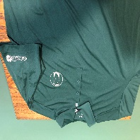
SIGCSA Merchandise Order Form
SHIRTS
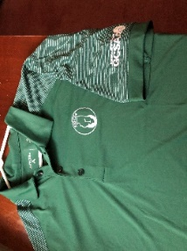
Shirt (Antigua Dark Pine & White) Shirt (Antigua Dark Pine)
Website price $43.00 Chapter logo & GCSAA logo
Cash price $38 Website price: $37
In stock sizes L, XL Cash price: $32
Size ____ Quantity _____ In stock sizes L, XL, XXL
Size ____ Quantity ____

OUTERWEAR
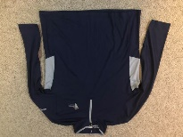
Puma ¼ zip pullover
(Navy with gray accent
50th Anniversary logo
Website price $45.00
Cash price: $40
In stock sizes L , XL, XXL
Size ____ Quantity _____

HEADWEAR
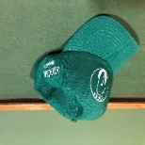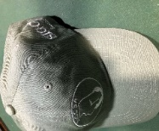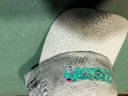
Cap (Imperial headwear) Cap (Imperial headwear) Cap (Imperial headwear)
Chapter logo Chapter logo GCSAA with SIGCSA Chapter
Grass Green Celtic Green Celtic Green
Website price $18.00 Website price $18 Website price $18
Cash price $16 Cash price $16 Cash price $16
Quantity ____ Quantity ______ Quantity ______
Ordering information:
To order and pay by credit card go to the SIGCSA website at sigcsa.com
Choose Membership/Payments in the menu and click on Items & support and scroll to the appropriate item you want to purchase. Multiple purchases will require separate transactions. Online purchases by credit card includes the swipe card transaction fee.

