Since 1971 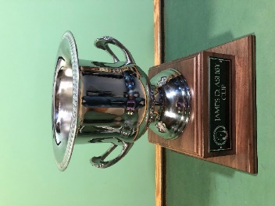
James D Ashby
Cup
Year | Venue | Winning Team
2021  2020 | Spencer T Olin GC | Union County CC
2019 | Stonewolf GC | MPR Supply
2018 | Tamarack GC | Green Hills CC
2017 | Gateway National GL | GreensPro
2016 | Spencer T Olin GC | Grand Marias GC
2015 | Greenview GC | Green Hills CC
2014 | Far Oaks GC | Green Hills CC
2013 | Sunset Hills CC | Union County CC
2012 | Links at Kokopelli GC | HMG Engineering
2011 | Annbriar GC | Green Hills CC
2010 | Green Hills CC | Green Hills CC
2009 | Sunset Hills CC | Sunset Hills CC
2008 | Sunset Hills CC | HMG Engineering
2007 | Sunset Hills CC | Sunset Hills CC
2006 | Far Oaks GC | Union County CC
2005 | Cardinal Creek GC | ?
2004 | Sunset Hills CC | ?
2003 | St Clair CC | ?
2002 | Sunset Hills CC | ?
2001 | Spring Valley GC | ?
2000 | Kokopelli GC | ?
1999 | The Acorns GC | ?
1998 | Green Hills CC | ?
1997 | Annbriar GC | ?
1996 | Cardinal Creek GC | ?
1995 | Annbriar GC | ?
1994 | Green Hills CC | ?
1993 | Cardinal Creek GC | ?
1992 | Greenview GC | ?

